March Branch Meeting ……
Saturday,
March 19,
9:30 a.m.

Touchmark Meeting Room – 19800 SW Touchmark Way
$15.00 for Breakfast or $5.00 for beverage only. DEADLINE for reservations (or cancellations): WEDNESDAY, March 16th by noon.
RSVP to Connie Brehm conniegbrehm@gmail.com or 541-647-0563

As always, we must ask no-shows and late cancellations to pay, as we are charged for all reservations.

AN EXTRAORDINARY WOMAN – Artist, Author, Instructor and Entrepreneur
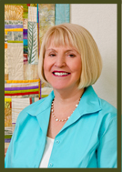
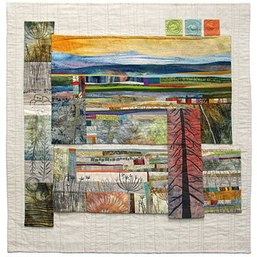
We are so happy to have Jean Wells as our March guest speaker. The list of her achievements is truly extraordinary. She is a quilt artist who has authored some 28 books on quilting. She instructs others on the art of quilting, and since 1975 she has been the proud owner of the Stitchin’ Post shop in Sisters, where she was the founder of the legendary Sisters Quilt Show. She has been named both Sisters Business Person of the Year and Sisters Citizen of the Year. Jean has also received the Michael Kile Award of Excellence for her contributions to the quilting industry. Six years ago she was inducted into the Quilters Hall of Fame in Indiana.

Jean will be bringing a variety of quilts to share with you. The focus of her talk will be on how her love of educating has shaped her business and led to a career of extensive teaching. Jean has a national reputation for the quality of her art as well as for inspiring people from all over the world to take up quilting. It promises to be a most memorable meeting.

Marilyn Coffel & Evie Lamb—Program Vice-Presidents

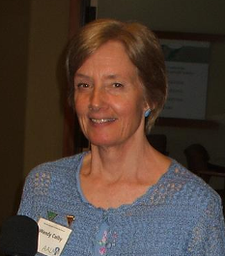
President’s Corner

Our branch has a wonderful opportunity to enhance our local scholarship fund. The Harmony4Women concerts donate proceeds to four organizations. A planning committee meets twice a month for one hour, April - December. Could you give 2 hours a month to serve on the planning committee? See page two for more information.
Wendy Colby

Guess what? Equal pay still doesn’t exist! Join a small committee to publicize the discrepancy on Equal Pay Day, April 12.

The Oregon State Convention will be held April 22nd - 24th in Medford. Consult the OREGON NEWS for all the information. Deadline to register with Ann Evensen is April 4th.

Membership Matters
By Linda Gardner, AAUW of Oregon Membership VP

From March 15th through June, a new member gets the rest of this year for free by joining now for next year (remember we have a fiscal year of July 1 to June 30). By the same token, anyone who wants to get a jump on next year's dues can pay for next year any time after March 15. Annual dues are $80.00, with $49 going to National ($46 is tax deductible), $16 to the State, and $15 to the Bend Branch. Questions should be addressed to Ann Overman, annrich@99west.com, or Linda Gardner, trixytazzy@live.com. Dues may be paid at meetings, or mailed to the treasurer, Sharon Keating, 17 SW Allen Road, Bend, OR 97702.

If you do not have your directory, which is mostly up-to-date, please let one of us know.

Harmony4Women Needs
an AAUW Volunteer
By Kathi Dew

In just two years, being involved with Harmony4Women has added $6500 to our scholarship fund to advance equity for women through education. Adding to that fund is a tremendous service to AAUW.

How was that done? Harmony4Women brings together a chorus of community women that spend a couple of months learning to sing together, and then perform a concert. Proceeds from this concert are split among the four member organizations. A planning committee meets from April to December on the first and third Wednesdays from noon to 1:00 p.m. to assure a well-planned benefit concert and silent auction. The planning committee is chaired by Linda Gardner and made up of representatives from Soroptimist, Grandma’s House, Bella Accapella, and AAUW. AAUW needs a new volunteer to serve on this committee. To volunteer or get more information, contact Linda Gardner.
Seeking Officers
for 2016-17
By Kathi Dew, Nominating Committee

Contact Evie Lamb or Kathi Dew if you are interested in one of these two positions.
- A Program Co-Vice President to manage the speakers’ slate for two years and organize any holiday gathering with elected Program Co-Vice President Evie Lamb.
- A Membership Co-Vice President to manage membership activities with Membership Co-Vice President Ann Overman. This is for one year since you will be completing an existing term. Tasks require computer skills to revise a membership brochure and produce our membership directory. Contact Kathi to discuss this possibility.
Candidates for these two positions will be presented no later than two weeks before the March branch meeting for election at that meeting. Though installation won’t be until the May meeting, attending the state convention in April is encouraged and would provide useful officer training.

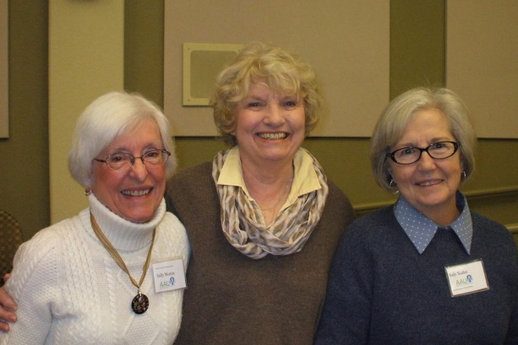
Sally Morton, Milree Latimer, Judy Scales

“When we do the best we can, we never know what miracle is wrought in our life, or in the life of another.”
Helen Keller

Voting – Making Your Voice Heard
By Marlene Kull, Public Policy Chair

With elections coming up soon, one of the ways you can help advance the AAUW mission of equity for women and girls is to register to vote, become educated on the issues and candidates, vote for the candidates that best support the AAUW mission, and contact them when important legislation is up for a vote.
Following is the AAUW Candidate Voting Guide that can assist you when vetting the candidates. Ask your candidates if they SUPPORT or OPPOSE..........
*Passing legislation that would provide paid parental leave for all employees,
including those that work for the federal government.

*Strengthening Social Security for future generations, including Social Security
Disability Insurance, which is currently the only form of disability insurance
most young adults possess.

*Passing legislation that would require companies to allow employees to earn
a minimum number of sick days each year.

*Passing the Paycheck Fairness Act, which would update equal pay laws and
improve the enforcement of existing civil rights laws aimed at closing the gender pay gap.

*Access to affordable birth control and family planning by supporting funding for Title X
family planning programs and coverage requirements under the Affordable Care Act.

*Confirming judges who uphold civil rights laws and establish legal precedents.

*Affirmative action programs that seek to break down the barriers confronting women and
minorities in education and employment.

*Increasing resources to promote prevention efforts and stronger enforcement of federal laws
prohibiting campus sexual harassment and violence.

*Increasing funding for student loan forgiveness programs, Pell grants and
other college affordability programs.

The Oregon Legislature is currently in session and AAUW Oregon is contacting members through AAUW Action Network when your voice needs to be heard regarding important legislation. Make sure you are signed up on the Action Network and contact your legislator in a timely manner when a notification comes through. http://www.aauw.org/what-we-do/public-policy/two-minute-activist/

Also, if you are not registered to vote, or are not sure, go to the My Vote-Secretary of State website and check your status and/or register. https://secure.sos.state.or.us/orestar/vr/showVoterSearch.do

The power of AAUW is in the total sum of the individual support each member gives. Support the power of AAUW by learning about the candidates and issues, and then VOTING.



AAUW of Bend Branch Meeting
February 20, 2016 Minutes
By Maggie Matthias, Co-Secretary

The meeting was called to order by President Wendy Colby at 10:00 a.m. Joan Hinds introduced her guest, Ann Nyaradi. New members Shannon Kearney and Judy Scales were introduced. The pot was circulated to collect loose change to go to LAF to support plaintiffs in sex discrimination lawsuits.

Marilyn Coffel introduced the speaker, Linda Piacentini, a calligraphy artist and teacher whose work focuses on the creation of The Artist Book. Her work is represented in many galleries. She shared examples of her beautiful work illustrating the variety of purposes and forms, which the "artist book" can take.

Business Meeting:
The minutes of the January meeting, as printed in The FOCUS, were approved.

Finance – Sharon Keating
There were no questions on the Treasurer's report as presented in The FOCUS. The report will be filed for examination.

Membership – Ann Overman
Current membership is 74. Linda Gardner reminded members to encourage potential new members to join after the March 15th deadline for the special rate of $80 which covers the cost for the rest of this year and all of next year.

Nominations – Evie Lamb
It was reported that several elected positions need to be filled: Co-Vice President for Program; Co-Vice President for Membership and Finance Vice President. Registrars will be appointed.

STEM – Wendy Colby reported on the Science & Engineering Fair. Fifteen members helped in making this annual event an energetic and exciting affair for the Girl Scouts who participated. The speaker was Sarrah Hadiji, a chemical engineer who explained her current research project and its importance in pediatric chemotherapy. The Bend Bulletin covered the event in an article, which included photos.

College and University Connection
The active student branch of AAUW will be hosting a Science Fair competition to be held Saturday, March 5th at COCC. Wendy requested volunteers from our membership to help during the competition and to serve as judges. The time is 8:00 a.m. to 1:45 p.m.

Harmony4Women
Proceeds were $3,000, which were transferred to the scholarship fund housed at the Oregon Community Foundation. The Scholarship Committee is looking for 2 or 3 new members. Reading of the applications and the final determination of scholarship recipients takes place in early June.

AAUW Funds – Brenda Sullivan
The event for this year will be a Virtual Dinner Out. Menus from a top restaurant will be distributed and members are invited to "choose their order" from the listed options and to write their checks to cover the cost. Donations are tax deductible.

Program – Our program speaker for the April meeting will be Jean Wells. She was influential in creating the now world-famous Sisters Quilt Show.

Announcements:
Officer reports are due to state counterparts in February with a copy going to Wendy.
4th Muse Conference is March 4th through 6th.
League of Women Voters is beginning a membership drive.
Watch for Trish Garner's AAUW Two Minute Activists’ network contest.
State Convention is April 22 - 24 in Medford. Register by April 4.
Silent auction for the convention - each branch is encouraged to send only two baskets.

The Women’s Foundation of Oregon, with a financial base of 4 million dollars, provides services to agencies mostly in the Portland area. They are conducting "a listening tour" that includes Bend to determine the true status of women and girls in Oregon. The innovative quality of their methodology and data collection promises to determine some very interesting information.

Carol Miller, former member of our branch who moved to Portland, passed away after surgery.

There being no further business to come before the branch, the meeting was adjourned at 11:30 a.m.
Financial Report
February 20, 2016
CHECKING
Operating Funds | 2,332.57
Restricted Funds
Spa Auction | 1,000.00
NCCWSL Scholarship | 187.78
Helping Hand Fund | 27.03
Legal Advocacy Fund | 177.77
Restricted Funds Total | 1,392.58
TOTAL CHECKING (Operating Funds + Restricted Funds Total) | 3,725.15

Budget vs. Year-to-Date
EXPENSES | 15-16  BUDGET | 15-16 ACTUAL
Expenses from operations
Weil Scholarship Awards | 30.00 | 0.00
STEM | 100.00 | 76.30
Insurance & Fees | 275.00 | 245.00
Membership Expense | 100.00 | 0.00
Newsletter  Let’s Do Lunch at Jersey Mike’s  On Emerson with Five Guys Burgers & Chipotle  Thursday, March 24 at 11:30 a.m.  Their menu has hot and cold subs, salads, and wraps.  If your heart is set on a burger, go to Five Guys next door and join us at Jersey Mike’s!  If the weather is nice – and it will be spring – we can sit outside and soak up some sun!  RSVP no later than Wednesday, March 23 to howardkathidew@msn.com or call Kathi at 541-678-5712.  Your reservation allows Kathi to save enough space for everyone. | 50.00 | 0.00
Programs | 300.00 | 64.73
State Convention | 400.00 | 0.00
Past President’s Recognition | 0.00 | 0.00
President’s Travel Expense | 250.00 | 200.00
Office & Misc. Expense | 175.00 | 0.00
TOTAL EXPENSES | $1,680.00 | $586.03
Sharon Keating, Finance Vice-President

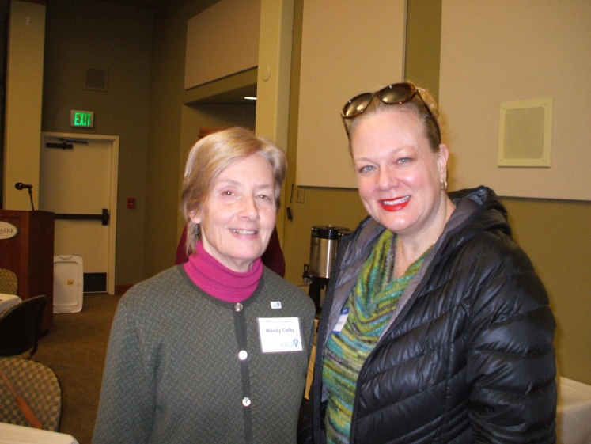

Wendy Colby with new member, Shannon Kearney

League of Women Voters

FIRST THURSDAY LUNCHEON
March 3, 2016, 11:00 a.m. – 1:00 p.m.
Black Bear Restaurant

More About Housing!
The speaker is County Commissioner, Tammy Baney, who has served on the seven-member Oregon Housing Stability Council since 2010.
Please arrive by 11:00 a.m. if ordering from the menu. The speaker will begin at noon. There will be time for questions at the finish of the presentation. No RSVP is needed.

Branch Interest Groups

NOON BOOK REVIEW

Coordinator: Wendy Colby
541-385-5261, wendy@wildwilderness.org
Monday, March 21, at 12:00 p.m.
The group will meet at the home of Kathy Blake and Kay Coyner (61521 Sunny Breeze) to discuss Girl on the Train by Paula Hawkins. Please bring your own lunch. Beverages and dessert will be provided. If you plan to attend, please contact Kathy at kblake@bendbroadband.com or 541-382-7375.

EVENING BOOK REVIEW
Coordinator: Ann Evensen
541-382-1783, evensenann@bendcable.com
Monday, March 28, at 7:00 p.m.
The group will discuss the Novel Idea selection, Euphoria by Lily King. The group will meet in the small lounge in the Terrace Lodge at Touchmark. This is the same building where our branch meetings are, but turn right when you go by the reception area instead of left. New members are always welcome.

INTEREST GROUPS
POLICY REMINDER: Interest groups are open to anyone. However, group members must join AAUW of Bend if eligible for membership. All of the branch interest groups welcome new members unless a group has a maximum due to space considerations. If you would like to visit or join one, call the leader for information.

If you have questions or ideas for additional groups, contact President Wendy Colby.

GREAT DECISIONS

Coordinator: Laurel Sorlie
541-322-9470, sorlieol@bendcable.com
Tuesday, March 15, at 12:30 p.m.
Bend Golf and Country Club

The topic this month will be “The Future of Kurdistan.” Carol Cavoretto will lead the discussion. If you wish to order lunch, please arrive by 12:00 noon. The discussion will begin at 12:30 p.m.

The Great Decisions material is prepared by the Foreign Policy Association and includes a manual and video that is watched at the monthly meeting. We welcome new members!

THEATRE GROUP

Coordinator: Joan Hinds
541-317-5972, jx2hinds@bendbroadband.com
March 20, at 2:00 p.m.

The AAUW Theatre Group will be seeing Vanya and Sonia and Masha and Spike at Cascades Theatrical Company (CTC) at 148 NW Greenwood Ave. Tickets are $20 for adults and $16 for seniors. Please call Joan at jx2hinds@bendbroadband.com or 541-420-5650 to reserve your ticket before March 4th.

About the play:
"What happens when your daily routine is upended? It’s a lovely day at the farmhouse in Bucks County, PA where siblings Vanya and Sonia live and complain about their boring lives. Their typical morning of drinking coffee and waiting for the daily arrival of a Blue Heron is interrupted by their prophetic housekeeper, Cassandra, issuing an obscure and dire warning. Then a surprise visit from the movie star sister, along with her newest “beloved,” turns their lives upside down with the prospect of having to attend a neighborhood costume party, where they are to be Masha’s lowly entourage, and the recipient of some very upsetting news. What ensues is author Durang’s signature blend of neuroses and absurdity, and a lot of fun."

THE FOCUS
Bend AAUW
60945 Onyx St
Bend, OR 97702

AAUW ADVANCES
EQUITY
FOR WOMEN AND GIRLS THROUGH
ADVOCACY,
EDUCATION,
PHILANTHROPY,
AND RESEARCH.

Next Board Meeting:
March 14, 5:15 p.m.
Bend Public Library
(Call Wendy Colby to place
items on the agenda.)

President
Wendy Colby, 541-385-5261
wendy@wildwilderness.org

Membership
Ann Overman, 541-388-9983
annrich@99west.com

Editor, The FOCUS
Sarah Elmer, 541-389-2846
selmer@bendcable.com

THE FOCUS DEADLINE:
March 24, 2016

AAUW WEBSITE
www.aauw.org

AAUW OREGON WEBSITE
http://aauw-or.aauw.net

AAUW BEND BRANCH WEBSITE
http://bend-or.aauw.net

March, 2016

Sunday | Monday | Tuesday | Wednesday | Thursday | Friday | Saturday
 |  | 1 | 2 | 3  League of Women Voters | 4 | 5
6 | 7 | 8 | 9 | 10 | 11 | 12
13 | 14  Board Meeting | 15  Great Decisions | 16  Reservations Due | 17  St Patrick’s Day | 18 | 19  Branch Meeting
20  Theatre Group | 21  Noon Book Group | 22 | 23 | 24  Let’s Do Lunch  FOCUS Deadline | 25 | 26
27 | 28  Evening Book Group | 29 | 30 | 31

